**Project Description:**

* A given code with errors was given.
* Needed to figure out the errors in the given code and make the note taking app running and error free.

**Bugs and Fixes:**

* The HTTP request method – POST was not present. Added the POST method in the function definition where needed, both in python main file and the html home page code.
* request.args.get() was entered in the given code.This is used when GET method is used. Since POST method is used, replaced this with request.form() method to take in the input parameters.
* Added code to erase data in the html code.

**Broken Python Code:**

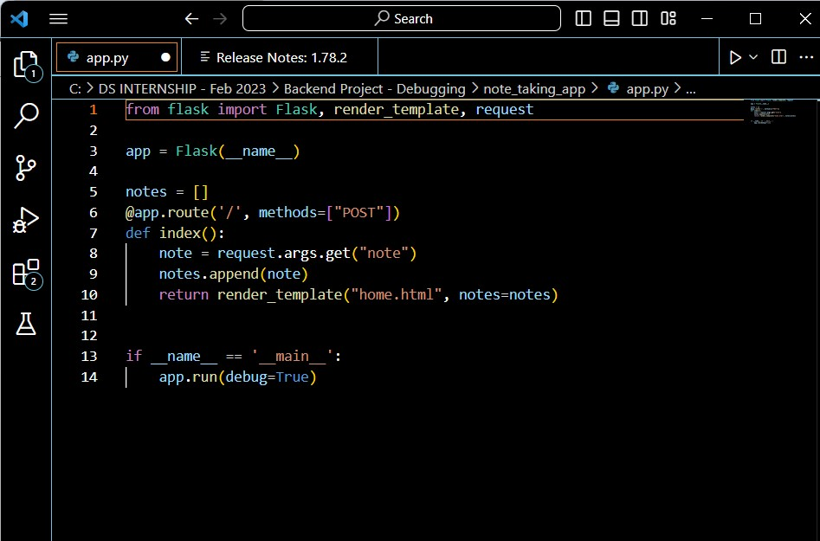

**Fixed Python Code:**

